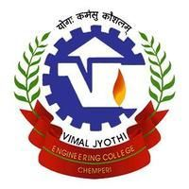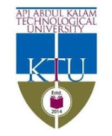

**DEPARTMENT OF ELECTRONICS AND COMMUNICATION ENGINEERING**

**VIMAL JYOTHI ENGINEERING COLLEGE**

*Cordially Invites You for the Inauguration of*

KTU SPONSORED

FIVE DAYS FACULTY DEVELOPMENT PROGRAMME

ON

**Interactive learning modules for innovative pedagogy in circuits and electronics**

**27th May 2019, 9.30 am at Varikkattu Hall**

*Kindly grace the occasion with your valuable presences*

**With regards**

**Dr. Roshini T V Mr.Anoop B K** *HoD /ECE/Co-ordinator FDP Co-ordinator-FDP*

***and all the teaching and non-teaching staff of ECE Department***

**Program Schedule**

|  |  |
| --- | --- |
| ***Prayer*** | : 9.30am |
| ***Welcome Speech*** | : Dr. Roshini T V (*HoD , ECE Dept.)* |
| ***Presidential Address*** | : Dr. Benny Joseph *(Principal VJEC)* |
| ***Inauguration*** | : Prof. Edamana Prasad *(Head, TLC,IIT Madras)* |
| ***Blessing Speech*** |  |
| ***Special Address by Guest of honour*** | : Prof. Ajit Kumar Kolar (Professor,IIT Madras) |
| ***Vote of Thanks*** | : **Mr.Anoop B K** *(Assisstant. Professor ECE Dept.*  *Co-ordinator, FDP)* |